Readme.doc

Obs: number of observations from 1 to 571
AgeR: age by range:
1= 0_17
2= 18_24
3= 25_34
4= 35_44
5= 45_54
6= 55_64
7= 65_75
8= 76_+
Gender: gender
1=male
2=female
Education: education
1= Primary
2= Secondary
3= Higher
Province: province of residence
22=Huesca
44=Teruel
50=Zaragoza
HSize: number of members in the household (continuous)
Income: Net monthly income of the household
1= Less than 1.000 €/month
2= 1,001 – 1,500 €/month
3= 1,501 – 2,000 €/month
4= 2,001 – 2,500 €/month
5= 2,501 – 3,000 €/month
6= 3,001 – 3,500 €/month
7= More than 3,500 €/month
98= I do not know / I do not want to say
IS_place: Importance attached to the place of purchase when shopping fresh vegetables
IS_organic: Importance attached to the organic method of production when shopping fresh vegetables
1= not important at all
2= Somewhat important
3=Important
4=Very important
5=Extremely important
Hypermarket: shopping vegetables at hypermarkets
1= yes
0= no
EatDailyVeg: eats vegetables daily
1=yes
2=no
Know: Knowledge on the method of product of vegetables they buy
1= Never
2= Hardly ever
3= Sometimes
4= Most of times
5= Always
Attitudes towards vegetables from local landraces
Att_Tasty: tasty
Att_Help: help to obtain higher benefits
Att_Fresh: fresh
Att_biodiversity: maintain the biodiversity
Att_Healthy: healthy
1= not association
2= low association
3= medium association
4= high association
5= very high association
IP: Intention to purchase vegetables from local landraces in the future
1= No
2= Probably no
3= I do not know
4= Probably yes
5= Yes
BEST-WORST EXPERIMENT

Some fresh vegetables sold in the market are produced in a specific place or following a specific production process and, therefore, carry a logo or seal that informs and certifies these characteristics that differentiate them. Some of these possible logos are shown in the following table. Read the description of each of them:
Label | Description
1.- Organic | It indicates that the food has been produced through a combination of the best environmental practices, a high level of biodiversity, the preservation of natural resources and the application of high animal welfare standards.
2.- Protected Designation of Origen (PDO) | It identifies a food produced in a given region whose quality is essentially due to the particular geographical environment and whose production stages take place entirely in the defined geographical area.
3.- C’Alial Brand   | It is a guaranteed brand of the Government of Aragon that indicates the quality of foodstuffs that meet the requirements established by the Department of Agriculture, Livestock and Food.
4.- Zero Kilometre  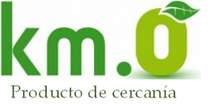 | It indicates that the food has grown close to where the consumer lives, within a maximum radius of about 100 kilometres.
5.- Local sales  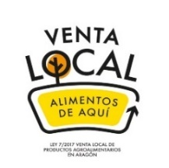 | It indicates that the food is sold by direct sale or using a short marketing channel. Direct sales are the sale made directly by the farmer or group (at the farmer's own holding, home, producer's shop, at fairs or local markets or to consumer groups). Short-channel sales are sales made by the producer or a group of producers through, at most, a single intermediary.
6.- Local landrace variety | It indicates that the food comes from a traditional local variety, which is one that is adapted to the local growing conditions and has been produced in a certain region over time by local farmers. Farmers pass on knowledge, cultivation techniques and seeds from generation to generation.
7.- Producer Collective Brand  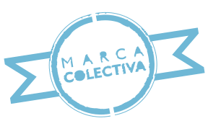 | It is a brand that belongs to an association of producers and serves to distinguish the products of its members on the market. These products have differentiated qualities, or characteristics established in the regulations for the use of the brand.

Imagine you are going to buy fresh vegetables. Tick the label that is most important to you when shopping for fresh vegetables and the least important one.

P17a-Most |  | P17b - Less
☐ | 3.- C’alial Brand | ☐
☐ | 6.- Local landrace variety | ☐
☐ | 1.- Organic | ☐
P18a - Most |  | P18b - Less
☐ | 2.- Protected Designation of Origen (PDO) | ☐
☐ | 1.- Organic | ☐
☐ | 4.- Zero Kilometre  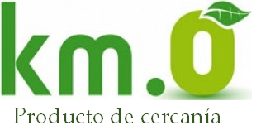 | ☐
P19a - Most |  | P19b -Less
☐ | 1.- Organic | ☐
☐ | 5.- Local sales  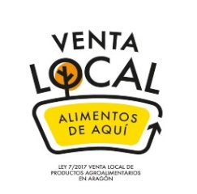 | ☐
☐ | 7.- Producer Collective Brand | ☐
P20a -Most |  | P20b - Less
☐ | 5.- Local sales | ☐
☐ | 3.- C’alial Brand | ☐
☐ | 2.- Protected Designation of Origen (PDO) | ☐
P21a Más importante |  | P21b Menos importante
☐ | 7.- Producer Collective Brand | ☐
☐ | 4.- Zero Kilometre | ☐
☐ | 3.- C’alial Brand | ☐
P22a - Most |  | P22b - Less
☐ | 6.- Local landrace variety | ☐
☐ | 2.- Protected Designation of Origen (PDO) | ☐
☐ | 7.- Producer Collective Brand | ☐
P23a - Most |  | P23b - Less
☐ | 4.- Zero Kilometre | ☐
☐ | 5.- Local sales | ☐
☐ | 6.- Local landrace variety | ☐

